Welcome to the Office of Research Compliance
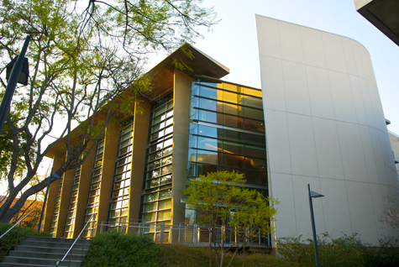
The California Institute of Technology is committed to the highest standards of integrity in fulfilling its mission to expand human knowledge and benefit society through research. All research activities undertaken by faculty, staff, and students at Caltech will be conducted in accordance with strict ethical principles and in compliance with federal, state, and institute regulations and policies. The Office of Research Compliance, which reports to the Vice Provost for Research, is responsible for providing support and training to faculty, students and staff in order to meet these requirements and maintain a robust research compliance program at Caltech.

Committees:
- Animal Research (IACUC)
Megan Ellison x8448
- Human Subjects Research (IRB)
Junie Hildebrandt x4699
- Biosafety (IBC)
Junie Hildebrandt x4699

Compliance Areas:
- Conflicts of Interest
- Responsible Conduct of Research
- Research Misconduct
- Controlled Substances
CCSC EHS: x6727
CCSC OLAR: x3454
- Export Compliance
OEC x2641

Data & Facilities Use:
- Facilities Use/Technical Services
- Data Use/Sharing (NIH Forms)
The Office of Research Compliance works with faculty oversight committees to promote the ethical and responsible conduct of research and to ensure compliance with regulatory requirements relating to research involving human and vertebrate animal subjects, recombinant DNA, biohazards, radioactive materials and stem cells. The committees supported by this office include the Institutional Animal Care and Use Committee (IACUC), the Institutional Review Board (IRB), and the Administrative Committee on Biosafety. The Office of Research Compliance also has responsibilities relating to responsible conduct of research, conflicts of interest, controlled substances, compliance with U.S. export control regulations, and third party use of Caltech's research facilities.

To Contact Us

Kaushik Bhattacharya - (626) 395-6365
Vice Provost for Research

Grace Fisher-Adams - (626) 395-2907
Director of Research Compliance

Office of Research Compliance
MailCode: 104-31 1200 E California Blvd, Pasadena CA 91125
Tel: 626-395-2907
Email: orc@caltech.edu

